

TEST REPORT

Doc No: HTPL/FOR/ENGG/TR02
Ver: 1.2

DOCUMENT DETAILS

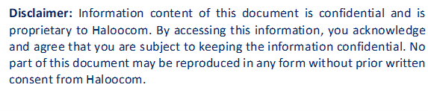

HTPL/FOR/ENGG/TR02

SOFTWARE TEST REPORT

OVERVIEW
Testing was completed by Sauravi and Mehul on June 20, 2025. New feature implementation was verified:
The objective was to implement and verify the new call-log report functionality for Mswipe Hexa, which displays connected call entries with comprehensive filtering and reporting capabilities.

SOFTWARE IDENTIFICATION
- Name: Mswipe Hexa.
- Module Name: Call-Log Reporting & Analytics.
- Version: 1.2

TEST DATES & DURATION
- Test Start Date: June 20, 2025
- Test Completion Date: June 20, 2025
- Test Duration: 1 day
- Test Effort: 2 person-days

TEST RESOURCES
People Involved
- Test Lead: Sauravi
- Test Analyst: Mehul
- Development Lead: Nagendra
- Developer: Sauravi

ISSUES RAISED
Bug ID | Description | Severity | Status
BUG_001 | New call-log report feature required to display connected call entries with filtering options for Mswipe Hexa client. Report should include call duration, agent details, and connection timestamps. | Low | Open

BUGS FIXED
Bug ID | Description | Fix Details | Status
BUG_001 |  | Implemented new call-log report module with connected call filtering. Added report generation functionality with date range, agent, and campaign filters. Created export options (PDF, Excel, CSV). Integrated real-time data refresh and pagination for large datasets. Added call duration analytics and connection success metrics. | ✅ Fixed
  New call-log report feature required to display connected call entries with filtering options for Mswipe Hexa client. Report should include call duration, agent details, and connection timestamps.

ADDITIONAL DETAILS
What Was Tested
- Call-log report generation functionality.
- Connected call entries filtering and display.
- Date range selection and filtering.
Summary
- Issues Resolved: New call-log report for connected call entries.
- Severity Range: Low
- Status: All issues resolved.
Workaround
- NA (Fixed in code directly)
Recommendation
Implement scheduled report generation for daily/weekly/monthly automated reports.
APPROVALS
Approver | Signature | Date

