

TEST REPORT

Doc No: HTPL/FOR/ENGG/TR05
Ver: 1.2

DOCUMENT DETAILS

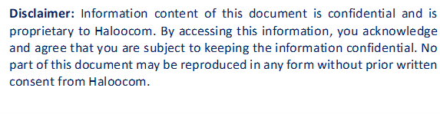

HTPL/FOR/ENGG/TR05
SOFTWARE TEST REPORT

OVERVIEW
Testing was completed by Sauravi and Mehul on July 08, 2025. Several issues were identified during the testing of the Total Dialled Minutes dashboard feature with custom date range functionality for MSwipe Hexa:
The objective was to implement and verify the dashboard analytics feature for displaying total dialled minutes with custom date range selection capability, ensuring accurate data aggregation, proper date filtering, and real-time dashboard updates with comprehensive error handling and data validation.

SOFTWARE IDENTIFICATION
- Name: Call Centre Software.
- Module Name: Dashboard Analytics Module - MSwipe Hexa.
- Version: 1.2

TEST DATES & DURATION
- Test Start Date: July 08, 2025
- Test Completion Date: July 08, 2025
- Test Duration: 1 day
- Test Effort: 2 person-days

TEST RESOURCES
People Involved
- Test Lead: Sauravi
- Test Analyst: Mehul
- Development Lead: Nagendra
- Developer: Sauravi

ISSUES RAISED
Bug ID | Description | Severity | Status
BUG_001 | Total dialled minutes calculation incorrect for custom date ranges in MSwipe Hexa dashboard. | Medium | Open

BUGS FIXED
Bug ID | Description | Fix Details | Status
BUG_001 |  | Corrected SQL query aggregation logic for date range filtering. Implemented proper timezone handling and UTC conversion for accurate time calculations. Added validation for date range boundaries and leap year considerations. | ✅ Fixed
  Total dialled minutes calculation incorrect for custom date ranges in MSwipe Hexa dashboard.

ADDITIONAL DETAILS
What Was Tested
- Total dialled minutes calculation accuracy across different date ranges.
- Custom date range picker functionality and validation.
- Dashboard data refresh and real-time updates.
Summary
- Issue Identified: Dashboard analytics for total dialled minutes with custom date range functionality.
- Severity: Medium.
- Status: Resolved
Workaround
- NA (Fixed in code directly)
Recommendation
Implement data pre-aggregation for commonly used date ranges and add drill-down capability to view detailed call statistics. Consider adding comparative analytics (month-over-month, year-over-year) and export functionality for dashboard reports.
APPROVALS
Approver | Signature | Date

